Office 365
- Click here for The Office 365 Training Center - this site has video tutorials for each application on the Office 365 software suite. Take some time to explore this page before moving on.
- Click on the "Start with 6 Simple Steps"
- Please note! When creating a course folder that is shared with a subject teacher, you will need to open the course folder and create all files from within that folder. OneDrive does not like to share files by moving them.

Signing and Getting In to Office 365
After running through all of the different things you can do, here to go to the actual website.
Click sign in, your username is “(student ID)@nbss.nbed.nb.ca” and your password will be whatever password you used to sign in on the computer with.

Office 365 - Customizing Your Profile

Note: In addition to customizing your profile, you can also install a free Office 365 on your home PC.
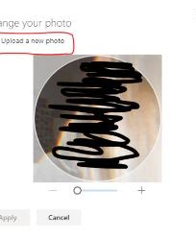
Now I would like you to personalize your account, what I mean by that is I would like you to select a photo and set it as a profile photo. If you have used google photos before you can save a picture to the computer, or you can use another free photos website and then upload them as your profile picture.
All you have to do is click on your initials (top right) and then click My Profile to edit your profile info.
- Click on upload new photo and then find your photo!
- You can also click on My Account for your free install of Office 365.

The other thing that you could do if click on your photo and then click “My Profile” then click update profile. That should take you to a page that looks like this. (see image below)
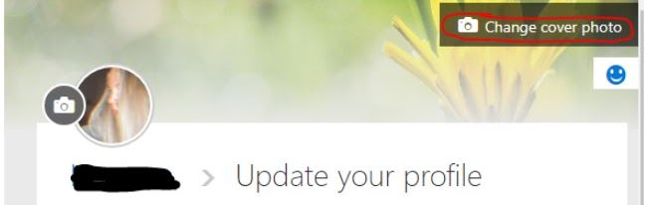
Click on change cover photo and you can select a new background and style too! (you don’t have to save because it does this automatically.

Office 365 - OneDrive
- Share your Folder
To start, I would like you to enter OneDrive and create a folder, name it BBT10_(LastnameFirstletter) and under sharing, click private, then click "Grant Access". Make sure you share the folder and not files. I would then like you to type in my email, malcolm.mulligan @nbed.nb.ca Value 5
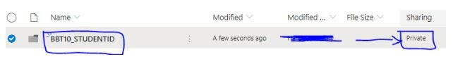

Office 365 - MSWord
You can use the "How To Write a Research Paper" for title page layout and how to cite works. You can get to it from the “Files” tab on the Team page.
- Click on Word and start a new document. Include a title page and write two or three paragraphs about what you think about teens getting jobs at young ages. You don’t need to do any research on the project, only express your thoughts. Name this document “TeenWork_(LastnameFirstLetter)” You can do this by putting your cursor over the name and clicking. Then enter OneDrive and put it into your shared folder. Value 5.
- Review Policy 311 (about 20 mins to go through it) found in the Files tab on the class teams site. The form doesn't need to be returned.
- Start a new document in Word, save it as “Policy” and write a 250 word report on Policy 311. Be sure to include a title page and works cited page. Save the file per my instructions above and name it, "Policy". Value 10.
- Start a new document in the Word, save it as “Plagiarizing” and write a 250 word report on Plagiarizing and How To Cite Works. Be sure to include a title page and works cited page. Save the file per my instructions above and name it, "Plagiarizing". Value 10.

Part 2: Digital Citizenship Education Units
- Core Technology Skills

Name your documents as assigned below and Submit all assignments at once (when finished) to the Digital Citizenship assignment in Teams.
- Digital Security: /10
- New Brunswick BBT Web Page link; click on Core Technology Skills
- go to the link above and complete the Digital Security assignment. Complete the assignment using Word in your One Drive. Only do Assignment 1.
- Save your file as: Security and put it in your shared BBT10 folder in YOUR EECD One Drive.
- Digital Communication: /30
- New Brunswick BBT Web Page link; click on Core Technology Skills
- go to the link above and complete the Digital Communication assignment1. Complete the assignment using Word in your One Drive. Only do Assignment 1.
- Save your file as: Communication and put it in your shared BBT10 folder in YOUR EECD One Drive.
- Digital Right & Responsibilities: /30
- New Brunswick BBT Web Page link; click on Core Technology Skills
- go to the link above and complete the Digital Rights and Responsibilities assignment (The Ten Commandments) Complete the assignment using Word in your One Drive.
- Save your file as: Right & Responsibilities and put it in your shared BBT10 folder in YOUR EECD One Drive.
- Digital Etiquette: /10
- New Brunswick BBT Web Page link; click on Core Technology Skills
- go to the link above and complete the Digital Etiquette assignment. Do only Assignment #2 (NETiquette). Complete the assignment using Word in your One Drive.
- Save your file as: Etiquette and put it in your shared BBT10 folder in YOUR EECD One Drive.
- Digital Wellness: /12
- New Brunswick BBT Web Page link; click on Core Technology Skills
- go to the link above and complete the Digital Wellness assignment. Complete only Assignment 1 using Word in your One Drive. You will not need to use the 2 meter sticks and other apparatus.
- Save your file as: Wellness and put it in your shared BBT10 folder in YOUR EECD One Drive.
- Digital Business: /11
- New Brunswick BBT Web Page link; click on Core Technology Skills
- go to the link above and complete the Digital Business assignment. Complete only Assignment 1 using Word in your One Drive.
- Save your file as: Business and put it in your shared BBT10 folder in YOUR EECD One Drive.
- Digital Access: /12
- New Brunswick BBT Web Page link; click on Core Technology Skills
- go to the link above and complete the Digital Access assignment. Complete only Assignment 1 using Word in your One Drive.
- Save your file as: Access and put it in your shared BBT10 folder in YOUR EECD One Drive.
- Digital Law: /34
- New Brunswick BBT Web Page link; click on Core Technology Skills
- go to the link above and complete the Digital Law assignment. Complete only Assignment 1 using Word in your One Drive.
- Save your file as: Law and put it in your shared BBT10 folder in YOUR EECD One Drive.
- Digital Literacy: /20
- New Brunswick BBT Web Page link; click on Core Technology Skills
- go to the link above and complete the Digital Literacy assignment. Complete only Assignment 1 using Word in your One Drive.
- Save your file as: Literacy and put it in your shared BBT10 folder in YOUR EECD One Drive.

Extras:
I use a couple of websites for creating my own custom text and logos. There are more than the ones that I use, but this is a good place to start.
Creating Custom Text and Logos
The two that I use are Flaming Text and Cool Text. Google search them and use them to create your own designs for text and logos.

Reference: https://sites.google.com/view/mrswimcourses/bbt-10-course-outline/new-bbt-10-assigned-work Office 365 Info and Lesson 1

