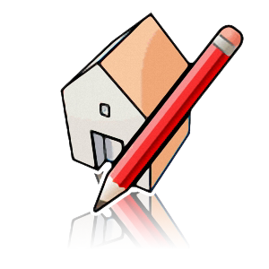

ONLINE VERSION

NAME: ___________________________________

Marking Evaluation:

Activity #1  Getting signed up-View Tools, Tool Bar ID, both left and right side- find 3D warehouse, and push pull tool. No need to save. | Complete: ___________
Activity #2  Practice- Line, Circle, Rectangle, Polygon and as many other tools in the bar. | Complete: ___________
Activity #3- PUSH/PULL- Practice and watch video. | Complete: ___________
Activity #4 – Building a Structure (Camp) Meter Template  - Height 2.75 m Floor 8m x8m  - Raise 0.15m pulled 0.60m  - Roof gap correct  - Roofing and Siding | Value 15: ___________
Activity #5 – Doors and Windows on your camp  - Gable Roof with overhang  - Shingled Roof  - Siding  - Door and Windows  - Dimensions  HIP ROOF VIDEO- https://www.youtube.com/watch?v=gepn1nYcYy8 | Value 15: ___________  Bonus value 5______________
Activity #6 – Follow Me Tool  - Square building with Molding  Cup /Wine Glass  - Water Tower | Value 20________
Activity #7 – Floor Plans  - Feet and inches TEMLATE  - Outside walls 10” walls  - Interior design, rooms  - Interior walls 8’  - Windows and Doors  - Furniture  - Roof, materials siding  - Landscaping | Value 25: _______
Activities #8- Chair Project  Chair Project- See Video | Value 10 ________  10 BONUS__________
Other Optional Bonus Project- Chess Piece
See video on building a chess piece- https://www.youtube.com/watch?v=e5dlxvjOsv4&t=2s

TOTAL 100____________
TEACHER COMMENTS
_____________________________________________________________________________________

